Chapter 2 Learning Guide – Population

Key Issue 1 – Where is the World’s Population Distributed?
Pgs. 44 – 53

Population Concentrations

- The world’s population is highly clustered, or concentrated in certain regions. FOUR major population concentrations are identified in the text. Shade and label the areas of these concentrations on the map in red. TWO smaller concentrations, or emerging clusters, are also identified. Shade and label these areas on the map in blue.

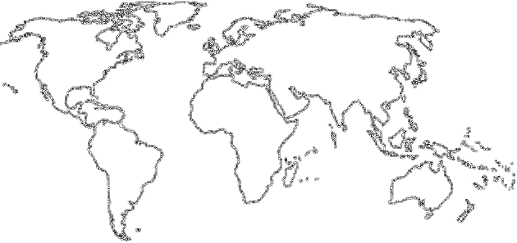

2.
In the boxes below, make note of significant facts, features, countries involved and characteristics of the four most important population concentrations and two secondary ones.
EAST ASIA |  | SOUTH ASIA
SOUTHEAST ASIA | EUROPE |  | EASTERN NORTH AMERICA  WEST AFRICA

Sparsely Populated Regions
- Define ecumene:

- What would non-ecumene mean?

- List the four “lands” which are sparsely populated in Earth in the table below. For each region, briefly explain the reason that makes it inhospitable for human habitation.
Sparsely Populated Land | Reason for Inhospitality
Dry Lands
Wet Lands
Cold Lands
High Lands
- Use the maps on page 49 to prepare a sketch map that shows non-ecumene and very sparsely inhabited lands.
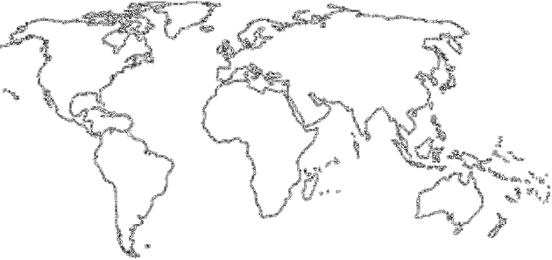

Population Density

- Define arithmetic density:

- Define physiological density:

- What occurs the higher the rate of physiological density?

- Define agricultural density:

Chapter 2 Learning Guide – Population

Key Issue 2 – Where Has the World’s Population Increased?
Pgs. 53 – 56

- Define crude birth rate (CBR):

- Define crude death rate (CDR):

- Define natural increase rate (NIR):

Natural Increase
- What is the NIR today?

- When did the global NIR peak, and what was it?

- About how many people are being added to the world’s population each year?

- Define doubling time:

- In what world regions is most growth occurring?

Fertility
- Define total fertility rate (TFR):

- What is the global “average” TFR?

- Note the rates and locations of the global “highs and lows” in TFR.
Mortality
- Define infant mortality rate:

- Define life expectancy:

- How are these mortality rates distributed globally, in terms of the developed and developing worlds?

Chapter 2 Learning Guide – Population

Key Issue 3 – Why is Population Increasing at Different Rates in Different Countries?
Pgs. 56 – 66

The Demographic Transition
- The demographic transition is a ________________________ with several ___________________ and every __________________________ is in one of the stages.

- Fill in the chart below with characteristics describing each stage in the demographic transition model (CBR, CDR, NIR, etc.). Characterize the amount of growth of each stage (low, moderate, high, etc.).
Demographic Transition Model
Stage 1 | Stage 2 | Stage 3 | Stage 4

- Read about how England passed through the various stages of the model on page 59 with Figure 2-17. Describe a historical event for stages 1 and 2 and a cultural attitude for stage 4.
Stage 1 Event | Stage 2 Event | Demographic Transition Model in England… | Stage 4 Attitude

Population Pyramids
- The shape of a pyramid is primarily determined by what demographic rate?

- What is the dependency ratio?

- What age groups are categorized as “dependent”?

- What does the “graying” of a population refer to?

- What is the sex ratio?

- What types of countries/regions are likely to have more males than females? Why?

Countries in Different Stages of Demographic Transition
- In the chart below, which represents the four stages of demographic transition, identify the country and where it is located which is in that stage and briefly describe how it got to that stage.
Stages of Demographic Transition: Example Countries
Stage 1 | Stage 2 | Stage 3 | Stage 4
No Country in
Stage 1
Demographic Transition and World Population Growth
- How many countries are in Stage 1 of the demographic transition?

- What portion are in Stages 2 and 3?

- And in Stage 4?

- Identify the two “big breaks” in the demographic transition and their causes.

- Complete the following statement: The first break came to Europe and North America as a result of…

- Complete the following statement: The first break came to Africa, Asia and Latin America as a result of…

Chapter 2 Learning Guide – Population

Key Issue 4 – Why Might the World Face an Overpopulation Problem?
Pgs. 66 – 73

Malthus on Overpopulation

- Complete the chart below to describe the views and theories of various population theorists.
Thomas Malthus | Neo-Malthusians | Critics of Malthus
Declining Birth Rates
- Where was Malthus right?

- In what way was Malthus mistaken?

- What two strategies have proven successful to lower birth rates?

- Take notes on important facts regarding the distribution of contraceptives.

World Health Threats
- What is “epidemiologic transition”?

- Complete the chart below with notes on the stages of epidemiologic transition.

Epidemiologic Transition
Stages 1 and 2 | Stages 3 and 4 | Possible Stage 5

