Chapter 11 Learning Guide – Industry

Key Issue 1 – Where is Industry Distributed?
Pgs. 344 - 349

- Define maquiladora:

Origin of Industry

- Regarding the Industrial Revolution: What? Where? When?

- Define cottage industry:

- How did the iron industry benefits from the steam engine?

- Define coke:

- How is the distribution of steel and iron industry influenced by coal?

- Why was development in transportation necessary?

- What two forms of transportation grew rapidly?

- How did the Industrial Revolution change textiles?

- How did the Industrial Revolution and factory system contribute to the need for food processing?

- Using the map on page 346, shade where the first rail lines opened in the United Kingdom.

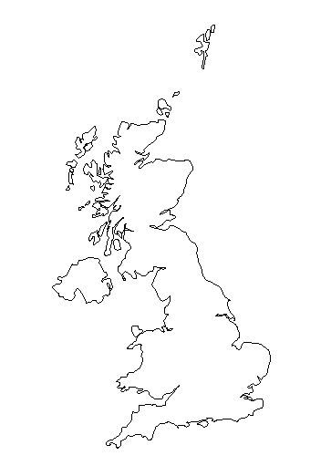

- Using the map on page 326, shade and label the hearth region of industrialization. And, which European regions were the last to receive the benefits of industrialization?

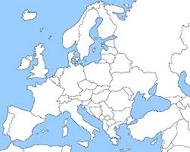

Industrial Regions

13. As you read the section, make notes on the resources, advantages, conditions, and issues in each of the sub regions of industrial development discussed. Shade and label each of the regions on the maps. (Use maps on pages 347, 348 & 349 as guides)

Europe

United Kingdom – | Rhine-Ruhr -
Mid-Rhine – | Po Basin -
Northeastern Spain – | Moscow -
St. Petersburg – | Volga -
Urals – | Kuznetsk -
Donetsk – | Silesia -

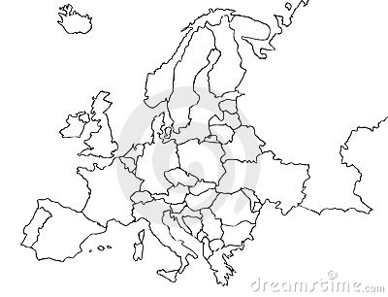
North America

New England – | Middle Atlantic -
Mohawk Valley – | Pittsburgh-Lake Erie -
Western Great Lakes – | Southern California -
Southeastern Ontario –

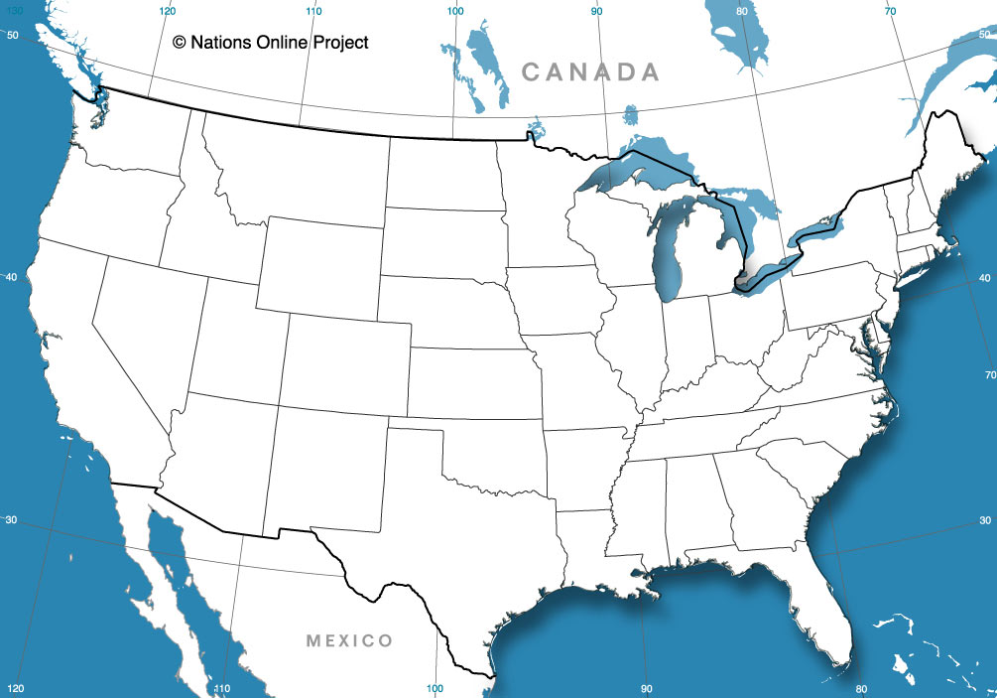

East Asia

Japan – | China -

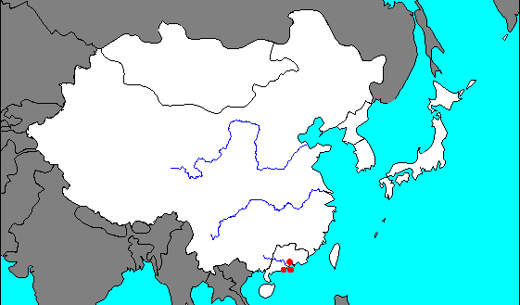
Chapter 11 Learning Guide – Industry

Key Issue 2 – Why Are Situation Factors Important?
Pgs. 350 – 355

- Define situation factor:

Proximity to Inputs

- What is a “bulk-reducing industry”?

- Make a brief flow chart to illustrate how copper is an example of a bulk-reducing industry.

- How does energy play a role in the situation of copper mills?

The text describes the changing location of steel mills in the U.S. Explain when and why each location was preferred.

- Pittsburgh, southwestern Pennsylvania

- Locations around southern shore of Lake Erie

- Southern Lake Michigan (Gary, Indiana & Chicago)

- East and West Coasts (Trenton, NJ & Los Angeles, CA)

- Why are the newest steel mills (minimills) beginning to move closer to markets and away from inputs?

- What is a “bulk-gaining industry”?

- Give two examples of these industries, and explain how they are bulk-gaining.

- Specialized manufacturers make products that are designed to be sold primarily to
_____________________________________________________.

- Where is their optimum location?

- Describe one example of this phenomenon.

- List examples of “perishable products” that must be located near their markets
- How is a newspaper highly perishable?

Ship, Rail, Truck, or Air?

- Give reasons for why each of the following modes of transportation might be selected by a manufacturer to deliver their products to market.

SHIP
RAIL
TRUCK
AIR

- What is a “break-of-bulk point”?

- Give two examples of important break-of-bulk points.

Chapter 11 Learning Guide – Industry

Key Issue 3 – Why Are Site Factors Important?
Pgs. 356 – 361

- Define site factor:

- What are the three production cost factors associated with the site of an industry? (Memorize Them!)

Labor

- Define labor intensive industry:

- What type of worker is required for the textile industry?

- What country accounts for most of the world’s spinning and weaving?

- Why do MDCs play a larger role in textile assembly than LDCs?

Land

- What are several (6 to be exact) factors about a given piece of land that make it attractive to industry and manufacturing?

Capital

- Describe the relationship between capital and the computer industry in California.

Chapter 11 Learning Guide – Industry

Key Issue 4 – Why Are Location Factors Changing?
Pgs. 361 – 368

Attraction of New Industrial Regions

- How are manufacturing jobs shifting in the U.S.?

- Define right-to-work laws:

- Why are southern right to work states attractive to companies?

- Why has textile production moved from the northeast to the southeast?

- What are the convergence regions?

- What are the competitive and employment regions?

- What makes central Europe attractive to manufacturers?

- Where has industry shifted internationally? And, name each regions leading industrial country(s).

- Sketch two pie graphs showing global steel for production for 1980 and 2008 shading MDCs and LDCs. (Use Fig. 11-25 as your guide)

- Use the map on page 364 to determine the following: Which groups accounted for more than 90% of global steel production in 1980? Who had the most rapid increase from 1980 to 2008?

- Why do transnational corporations transfer work to LDCs?

- What is the transfer of jobs known as?

- Define outsourcing:

- Provide an example of an industry that outsources, and what do they outsource?

Renewed Attraction of Traditional Industrial Regions

- What factors influence industry to remain in northeast U.S. or northwest Europe?

- Define Fordist:

- Define Post-Fordist:

- What benefits do the manufacturers receive from just-in-time delivery?

- How can labor unrest disrupt reliance on just-in-time delivery?

