Chapter 5 Learning Guide – Language

Key Issue 1 – Where Are English-Language Speakers Distributed?
Pgs. 134 – 143

- Define language:

- Define official language:

Origin & Diffusion of English

- How did English become widely diffused?

- What 3 European people originally came together to form the English people and English language?

- Where did these people come from?

- What 2 subsequent invasions added additional words to the evolving English language?

Dialects of English

- Dialects are defined as “regional variations of a language” and are distinguished by 3 things. What are they?

- Define standard language:

- What is the standard language for of English? Where did it come from (3 cities)? How was it diffused throughout Britain?

- In a single word, why is American English different from that spoken in England?

- Language differences, as exhibited in dialects tend to be greater in ___________________ _______________________ than in ______________________ because…

- People from all 3 eastern regions migrated into the Midwest, Great Plains and Western United States. Why is there a relatively uniform form of English (dialect) spoken across this enormous area?

Chapter 5 Learning Guide – Language

Key Issue 2 – Why is English Related to Other Languages?
Pgs. 143 – 151

- Define language family:

- Define language branch:

- Define language group:

Indo-European Branches

- Germanic Branch: Using the reading, complete this chart.

Germanic Branch
West Germanic Group | North Germanic Group

⬇ ⬇

- Indo-Iranian Branch: Make 2 bullets charts from the reading.
Iranian Group (Western) | Indic Group (Eastern)

Balto-Slavic Branch: Answer questions 6-10.

- How did Russian become the most important East Slavic language?

- What is the most important West Slavic language?

- Describe the controversy between Czech and Slovak languages under Czechoslovakia’s government? What happened?

- Why are South Slavic languages, which were once very similar to each other, becoming increasingly different today?

- The four most contemporary Romance languages are _________________________, ________________________, _________________________ & ______________________________.

- How did Latin languages diffuse in Europe? What happened to the native languages?

- Define Vulgar Latin:

- Why is it that nearly 90% of Spanish & Portuguese speakers live outside of Europe?

- Why is it difficult to distinguish individual languages from dialects?

- Define creolized language:

Origin & Diffusion of Indo-European

- What is the name of the (theoretical) common ancestral language of all languages discussed in this key issue of the chapter?

- Why is its existence difficult (impossible) to prove?

- Contrast the 2 views of the origin of this language in the chart below.

“Kurgan” Theory | Renfrew Hypothesis

Chapter 5 Learning Guide – Language

Key Issue 3 – Where Are Other Language Families Distributed?
Pgs. 151 – 156

Language Families of the World

Make brief notes on each of the following language families as you read about them in this section (i.e. how many people speak a language of that family, where spoken, common languages, etc.)

Indo-European Family:

Sino-Tibetan Family:

Austronesian Family:

Afro-Asiatic Family:

Niger-Congo Family:

Dravidian Family:

Japanese Family:

Altaic Family:

Korean Family:

Austro-Asiatic Family:
Tai Kadai:

Uralic Family:

Nilo-Saharan Family:

Khoisan Family:

Chapter 5 Learning Guide – Language

Key Issue 4 – Why Do People Preserve Local Languages?
Pgs. 156 - 164

- Prepare detailed notes with bullets and notations on the maps regarding the following case studies:
Nigeria: Problems in a multi-linguistic state (Figure 5-20)
Celtic Languages: The struggle for survival of a language family
Belgium: Political & linguistic divides

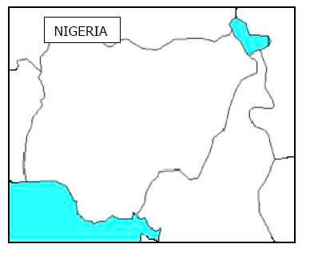

Notes:

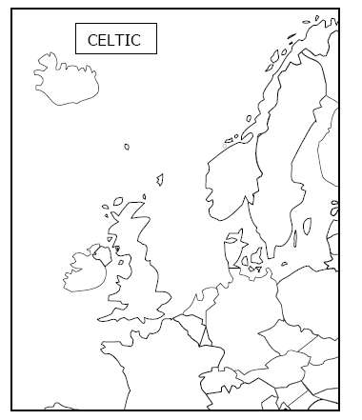
Notes:

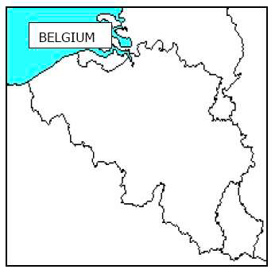
Notes:

- Complete the chart below by taking notes on the various languages/countries & the issues they are facing.

Hebrew –

Switzerland –

Basque –

Icelandic –

- Define lingua franca:

- Define pidgin language:

- How has expansion diffusion occurred with English?

